**M9D30AM – M2D35PM (diluted 1:1000)**

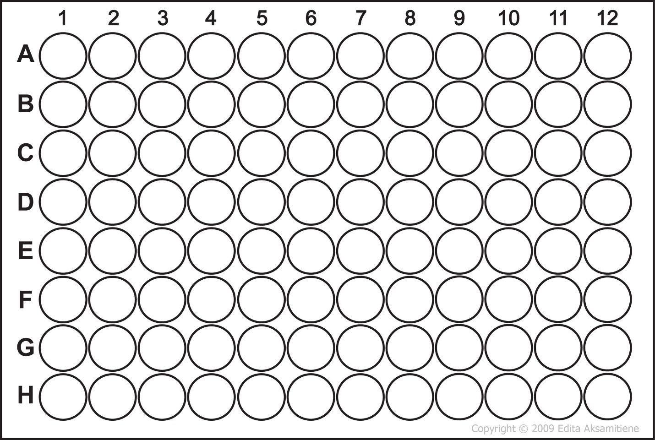

9d30am

7d32

3d32

2d35am

4d35am

6d35am

7d35am

9d35am

10d35am

2d35pm

10d33

9d33

7d33

6d33

5d33

4d33

3d33

2d33

10d32

9d32

8d32

4d32

2d32

10d31pm

9d31pm

8d31pm

7d31pm

6d31pm

5d31pm

4d31pm

3d31pm

10d31am

8d31am

7d31am

4d31am

3d31am

10d30pm

9d30pm

7d30pm

6d30pm

3d30pm

2d30pm

10d30am

